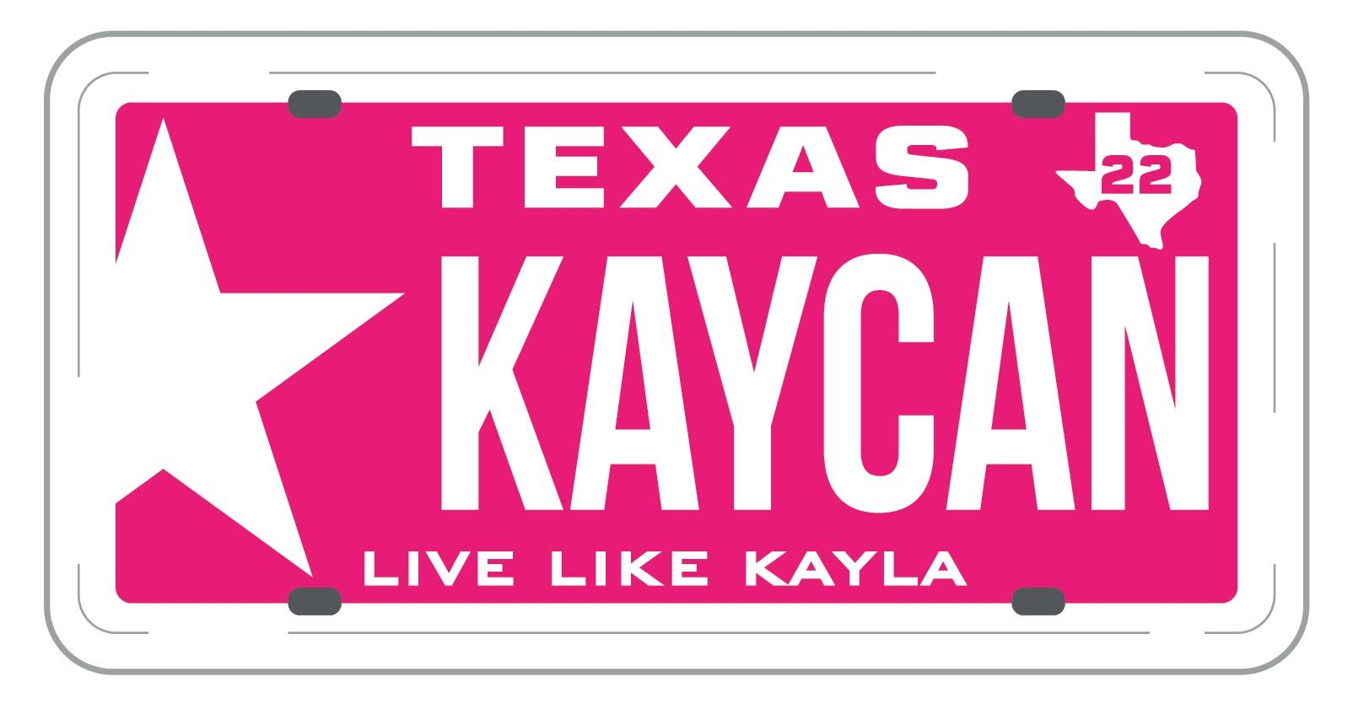
KAYCAN: Needs Based Application
With this application please include the following REQUIRED items:
- Essay – Answer the following in 250 words or less What one person or recent event has influenced you to pursue higher education and why?
- Completed KAYCAN Scholarship Application
- Two (2) Letters of Recommendation - One academic, one extracurricular/work related
- Attach a headshot photo of yourself
Student Name: ___________________________________________________ Address: ________________________________________________________ E-Mail: _____________________________Phone #: ____________________ Social Media Accounts: ____________________________________________
PERSONAL INFORMATION
1. What High School do you attend? ________________________________________________ 2. Who do you live with? _________________________________________________________ 3. 1st Parent/Guardian Occupation:_________________________________________________ 4. 2nd Parent/Guardian Occupation:________________________________________________ 5. Are you employed? ____________________________________________________________
i. If yes,where____________________________________________________________ ii. Length of time employed__________________________________________________
6. What are your plans for higher education after graduation? What do you plan to study?
____________________________________________________________________________
____________________________________________________________________________
____________________________________________________________________________
7. What are your life goals/objectives?
___________________________________________________________________________
___________________________________________________________________________
___________________________________________________________________________
___________________________________________________________________________
___________________________________________________________________________
8. If taken, SAT Score: EBRW:_________ Math:________(be prepared to provide proof if requested)
9. If taken, ACT Composite Score:__________ (be prepared to provide proof if requested)
10. HS Senior Fall Rank: #__________out of #__________
11. Current GPA:__________
EXTRACURRICULAR ACTIVITIES
Extracurricular Activity: _____________________________________________________________
Grade 9 Position Held: __________________________________
Hours/Week ________ Week/Year________
Grade 10 Position Held: __________________________________
Hours/Week ________ Week/Year________
Grade 11 Position Held: __________________________________
Hours/Week ________ Week/Year________
Grade 12 Position Held: __________________________________
Hours/Week ________ Week/Year________

VOLUNTEER SERVICE
Volunteer Service:
Place of Service: ___________________________________________________ Total Volunteers Hours completed: ____________________________________ Description of Service: ______________________________________________ From (date-mm/yyyy):______________ To (date-mm/yyyy):____________
Place of Service: ___________________________________________________ Total Volunteers Hours completed: ____________________________________ Description of Service: ______________________________________________ From (date-mm/yyyy):_______________ To (date-mm/yyyy):_______________
ADDITIONAL WORK
Place of work: ___________________________________________________ Total Hours per week: ______________________________________ Description of job performed: ________________________________________ From (date-mm/yyyy):_______________ To (date-mm/yyyy):_______________
Place of work: ___________________________________________________ Total Hours per week: ______________________________________ Description of job performed: ________________________________________ From (date-mm/yyyy):_______________ To (date-mm/yyyy):_______________
What other pertinent information would you like to share for consideration of a scholarship? Why should KAYCAN choose you? __________________________________________________________________________________________________________________________________________________________________________________________________________________________________________________________________________________________________________________________________________________________________________________________________________________________________________________________________________________________________________________________________________________________________________________________________________________________
Please email your application and required documents by March 24, 2024 to: kaycan22@yahoo.com

Kayla Cannon, KAYCAN, was determined, competitive and dedicated. Kayla held a 4.0 while involved in FFA and HOSA, competing in Volleyball while serving others and her community.
She continued excelling while in college, graduating a semester early while working a demanding job, being active in StuMo and Kappa Delta. Her summers were filled with traveling and mission work.
She never wasted one second!

